Bias-dependent Charge Transport Mechanisms and Nuclear Tunnelling in Molecular Junctions

*Ziyu Zhang1, Senthil Kumar Karuppannan1, Christian A. Nijhuis1,2\**

1 Department of Chemistry, National University of Singapore, 3 Science Drive 3, Singapore 117543, Singapore

2 Centre for Advanced 2D Materials and Graphene Research Centre, National University of Singapore, 2 Science Drive 3, Singapore 117542, Singapore

*Author to whom correspondence should be addressed: chmnca@nus.edu.sg

*Target journal:*

TOC:

Abstract:

**Introduction**:

* Objective:
  + To determine the charge transport mechanism in Fc-OPE junctions and the effect of applied bias from their length and temperature dependence.
* Why is it important:
  + We have systematically studied the temperature dependency of the charge transport in a conjugated system in a wide range of applied bias.
  + The bias dependence of the activation energy *Ea* shows a bell-shaped relationship, which does not fit into either Landauer or Marcus theory. This phenomenon can be explained by the work of Nitzan.
  + Although the LUMO of the molecules in gas phase are more than 2 eV apart from the Fermi level of studied metals, we believe they can be significantly reduced due to intramolecular gating effect and participate in the charge transport at negative bias.
  + The conjugated backbone based on OPE units is more rigid and gives rise to more robust monolayers in comparison to aliphatic SAMs such as FcC11SH. They have the potential to be used to studies where molecular orientations are important.
* Background:
  + The Fc-DPA-CH2SH molecule showed almost activationless charge transport and we believe the mechanism is the inverted Marcus regime. Here we are using a series of molecules that has a similar conjugated structure and expect to see the same behaviour.
  + Conjugated molecules have been tested in other research groups. However, EGaIn top electrodes have much weaker coupling strength with the molecules compared to metal tips. This allows the junctions to show more pronounced molecular effect compared to STM-BJ or CP-AFM used by others.

**Results and Discussion**:

* Figure 1 Schematic illustration of the junctions

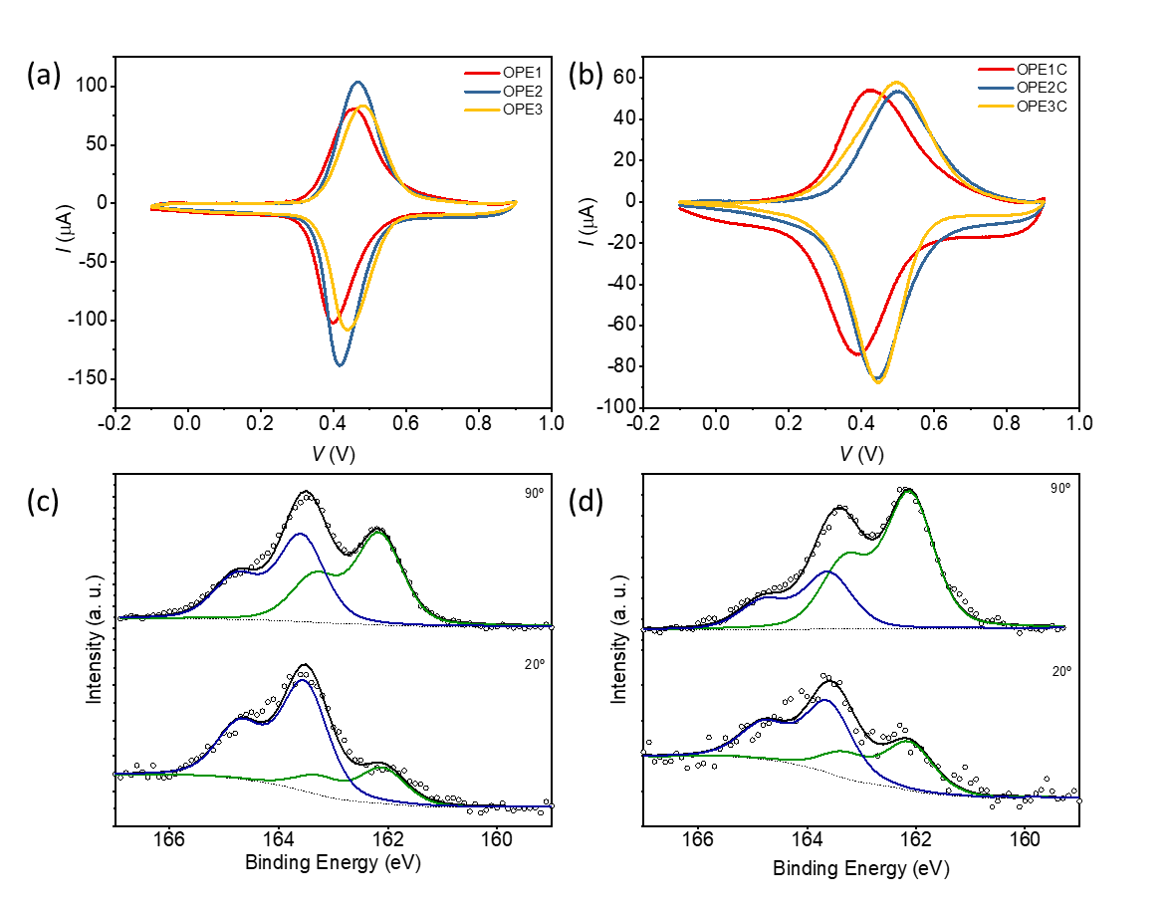

Figure 2. Surface characterisation of studied SAM: Cyclic voltammograms of (a) OPEn and (b) OPEnC measured at a scan rate of 1 V/s. S 2p XPS of SAM (c) OPE3 and (d) OPE3C at take-off angle of 90º and 20º.

* To characterize the structure of the SAMs, we ….
* Figure xx shows the cyclic voltammograms (CVs) of …
* Figure 2(a) and (b) shows that for all the SAMs in this study, a characteristic ferrocene redox wave is present at 0.4-0.5 V. Further peak deconvolution shows that with increasing number of phenylene ethynylene units, the oxidation waves are closer to a single gaussian function, indicating the molecules pack in a more uniform manner. We attribute this phenomenon to the increasing intermolecular interaction between the phenylene ethynylene units.
* In addition, the full width at half maximum (FWHM) values for the oxidation waves are ~130 meV for OPEn and ~210 meV for OPEnC. The FWHM for SAMs are determined by the electrostatic interaction between each molecule in the redox process. The larger FWHM values in SAMs of OPEnC also suggest that the molecules are closer to each other and have stronger repulsion when the ferrocene group are charged in the cyclic voltammetry process.
* In all XPS spectrum, chemisorbed thiolate peak at ~162.1 eV (green line in Figure 2(c) and (d)) and physisorbed thiol peaks at ~163.5 eV (blue line) are present. The CH2 groups between the phenyl rings and the thiolates increase the percentage of chemisorbed sulphur. We believe these conjugation breaking units help to weaken the interaction between the phenylene ethynylene units and the metal surfaces. As a result, more chemical bonding sites are opened during the formation of SAMs.
* UPS, NEXAFS, UV/Vis …



(a)

(b)

(d)

(c)

(f)

(e)

EGaIn

Au



n = 1

n = 2

n = 3

n = 1

n = 2

n = 3

-1 V

+1 V

n = 1

n = 2

n = 3

0 V

OPEn



EGaIn

Au

n = 1

n = 2

n = 3

n = 1

n = 2

n = 3

-1 V

+1 V

n = 1

n = 2

n = 3

0 V

OPEnC

*Γ*bottom

*Γ*top

*Γ*bottom

*Γ*top

Figure 3. The The Gaussian log-normal average current density as a function of voltage for (a) OPEn and (b) OPEnC. The current density at – 1V and + 1V bias as a function of the molecular length for (c) OPEn and (d) OPEnC. The energy level alignment in the junctions (e) OPEn and (f) OPEnC. The molecular length was determined by CPK model.

* Figure 3 shows at +1 V bias, the *β* values agree well with the other published values in several similar conjugated systems (0.3-0.5 Å-1). The charge transport mechanism is believed to be off-resonant coherent tunnelling. At -1 V bias, *β* becomes much smaller, indicating the mechanism has switched to hopping.
* Here it is worth noting that the general tunnelling equation $J(V)= J_{0}(V)e^{-βd}$ assumes a constant tunnelling barrier. But in a conjugated system, the tunnelling barrier is affected by both the molecular length and the coupling strength of the molecular HOMO and the metal electrodes.
* Figure 3 (e) and (f) illustrate the importance of the coupling strength in this junction. In these molecules the HOMOs mostly locate on the ferrocene groups but do delocalize over the entire conjugated backbone. When n = 1, the ferrocene group strongly couples with the bottom electrode. When n = 3 this coupling *Γ*bottom is much weaker. On the other hand, *Γ*top is determined by the Van Der Waals interactions between ferrocene and the EGaIn and do not change significantly with n. When a -1 V bias is applied to the junction, the HOMO movement is more prominent for OPE3 and OPE3C. As a result, the HOMO of the longest molecules enter the conduction window at the lowest bias despite that they are further away from the Fermi level at zero bias.
* Figure 3(c) and (d) shows *β* values for OPEnC SAMs are smaller than those for OPE SAMs at both biases. One possible explanation is that for OPEnC, the *Γ*bottom is smaller due to the conjugation breaker unit -CH2-. So at -1 V bias the HOMO level are closer to the top electrode, further reducing the tunnelling barrier.

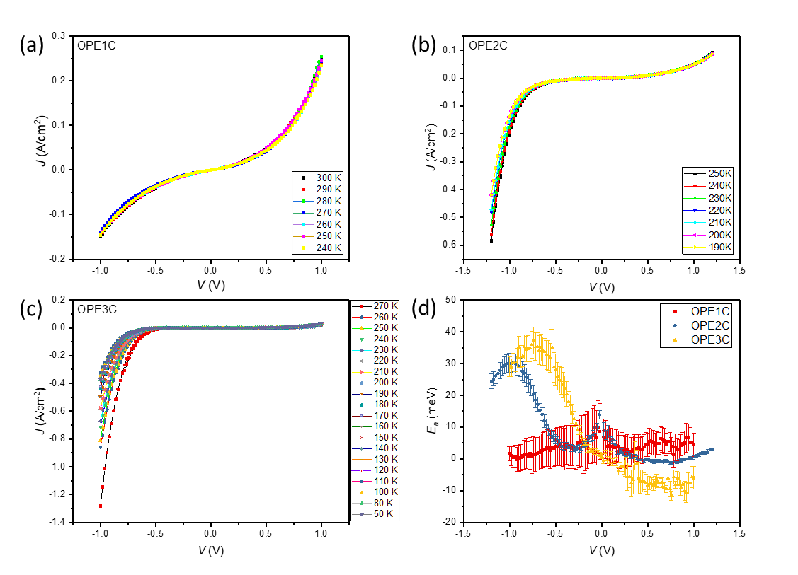

Figure 4 The temperature-dependent *J*-*V* curve for SAMs of OPEnC, (a) n =1, (b) n = 2, (c) n = 3. (d) The activation energy *Ea* at across the whole bias range. Repeated experiments are needed to have consistent temperature and bias range.

* Figure 4 (a) – (c) shows the *J*-*V* response of the junction when a smooth EGaIn surface is used as the top electrodes. The current densities of the junction are 10 – 100 times higher than the same junctions using cone-shaped EGaIn tips as the top electrodes due to higher effective contact area of the EGaIn surface. However, the rectification ratios of the junctions remain the same as the result showed in Figure 3, indicating the rectification is caused by the molecules themselves.
* Figure 4 (d) shows that at positive bias the charge transport by coherent tunnelling and the process is activationless (Ea ≈ 0). At negative bias, a bell-shaped curve of *Ea* vs *V* is observed for OPE2C and OPE3C. It is possible that this bell-shaped relation occurs at a higher bias for OPE1C and not observed here. This behaviour was predicted by Migliore et al. using a model based on Marcus theory applied in tunnelling junctions. The position of the peak could indicate the bias when the HOMOs of the molecules enter the conduction window (see Figure 5). The peak *Ea* values (30 - 40 meV) are lower than those for a typical hopping mechanism. We attribute this low Ea to the effect of nuclear tunnelling. The strong coupling between the ferrocene and the phenylene ethynylene units can make the charge transfer become non-adiabatic, lower the effective reorganization energy *λ*\*.



(a)

(b)

(c)

Figure 5 The normalized differential conductance (NDC) plot of junctions (a) OPE1C, (b) OPE2C and (c) OPE3C.

* Figure 5 shows for OPE1C, the NDC plot indicates off-resonant tunnelling. For OPE2C and OPE3C, the NDC shows a clear peak at negative bias, which is a characteristic diode behaviour. The peak position ( -1.1 V for OPE2C and -0.7 V for OPE3C) correlate with the peak in the *Ea*-*V* plot in Figure 4 (d). This confirms that the HOMO of OPE3C molecule enters the conduction window at a lower bias than the shorter molecules.
* As opposed to the current density and activation energy, the NDC plots do not show any obvious dependency to the temperature. NDC reveals the fine structures regarding the shape of the J-V curve. So we can conclude the charge transport mechanism does not vary in the temperature ranged measured this study.